4/12/2020

CMP4271 Professional Practice for Games Development

Task 8 – Digital to Physical

8.0 Introduction

The premises of today were to choose any digital game and create a physical copy of the game instead, such as a board game. The game chosen today was Grand Theft Auto 5. The game is both for one person and for several.

8.1 Materials

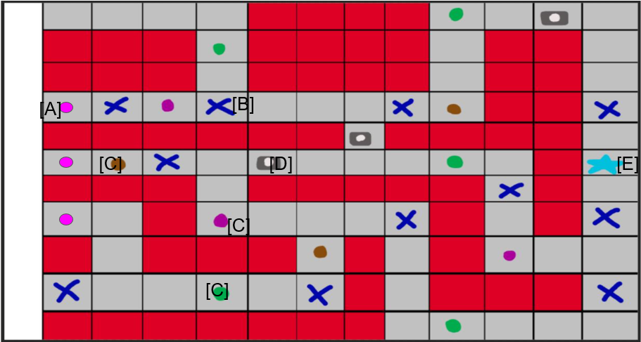

Figure 1. Gameboard. [A] are the players, [B] enemies, [C] are weapons ranging from knives to bombs, [D] are cameras and [E] is the goal.

8.2 Rules

The aim of the game is to carry out a heist on the bank and take the money by reaching the goal. Players need to navigate the board and fight police to reach their goal.

Mechanics

* Players move from one end of the board to the other using a pair of dice.
* These pair of dice are also used to determine whether they lose or win in a fight, when ending on the same block as an enemy
* Players shares 3 lives, once all lives are used up its game over.
* Within the game there are also cameras that when players land on them it forces them to go a square back instead.

8.3 Playtesting

There was one play tester. Their only feedback was to make the game have less police officers and make the walls more clear to the player.

8.4 Discussion

From creating the game, it was realised that the team had different tastes in games and therefore, it was hard to pick a game to recreate. This made us lose more time than we should have, which didn’t work in our favour as we worked to the last minute.

8.5 Reflection

The team I had worked with was Reece Taylor and Giancarlo Trinidad. I learned that making games would be easier if you had a larger variety of game knowledge. It would have been more useful during this task as none of us shared any games.